Project 5: Trivia Game – Walkthrough

1. App Launch Screen: The user is greeted with the title 'Trivial Trivia' and a start button labeled 'Let's go!'. This is the main entry point of the app where the game begins.

2. Trivia Question View: The app displays a progress bar at the top and shows the current question number out of total.

3. Questions and Answers: The current trivia question is shown in bold, followed by multiple answer choices. Users can tap to select an answer.

4. Answer Selection: When an answer is selected, a checkmark (if correct) or a cross (if incorrect) appears, along with colored borders to indicate correctness.

5. Next Question: After selecting an answer, the 'Next' button becomes enabled, allowing the user to proceed to the next question.

6. Completion Screen: Once the quiz is complete, the app congratulates the user and displays the final score. A 'Play again' button allows the user to restart the quiz.

7. The design uses vibrant colors and bold text styles to make the interface engaging and readable.

Figure 1: Screenshot from the Trivia Game App

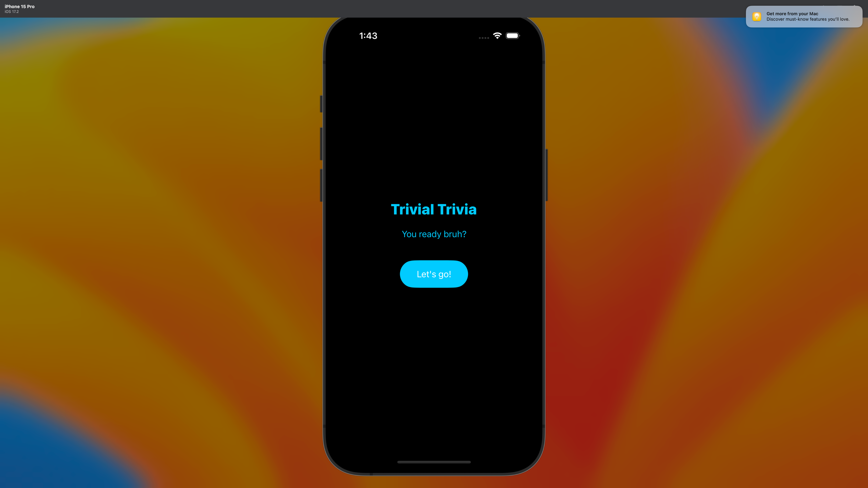

Figure 2: Screenshot from the Trivia Game App

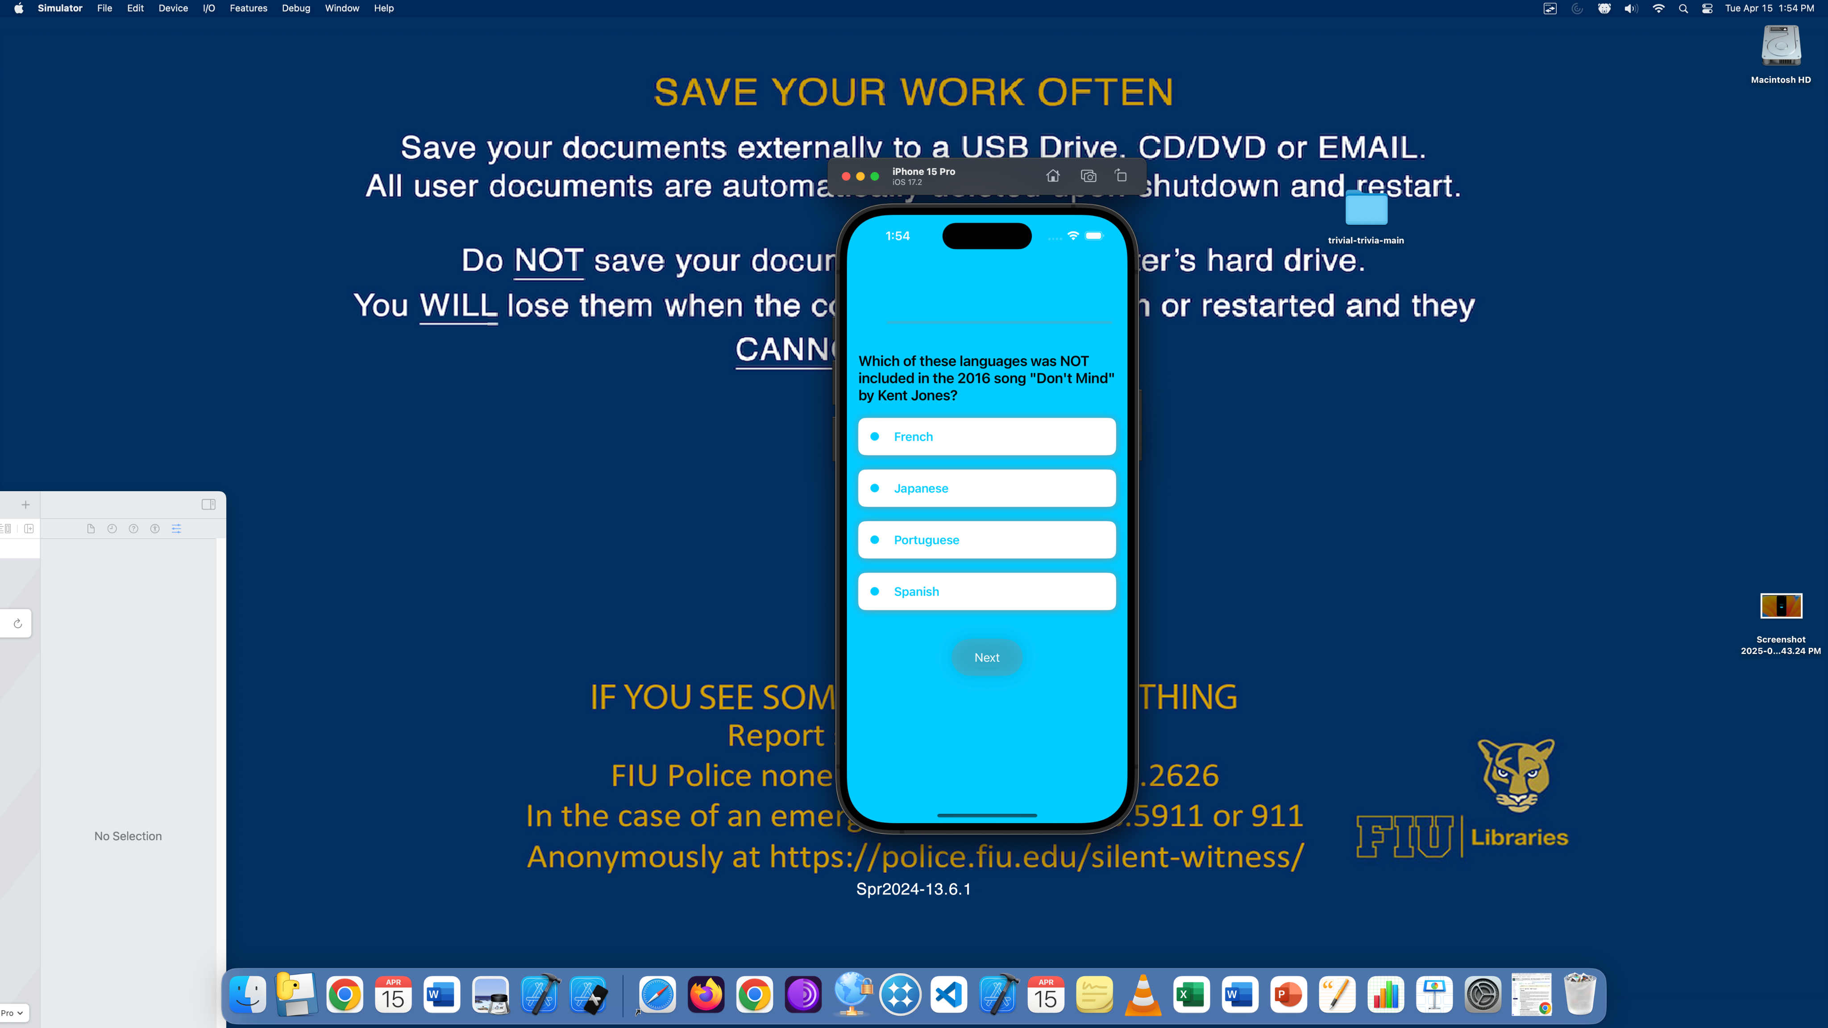

Figure 3: Screenshot from the Trivia Game App

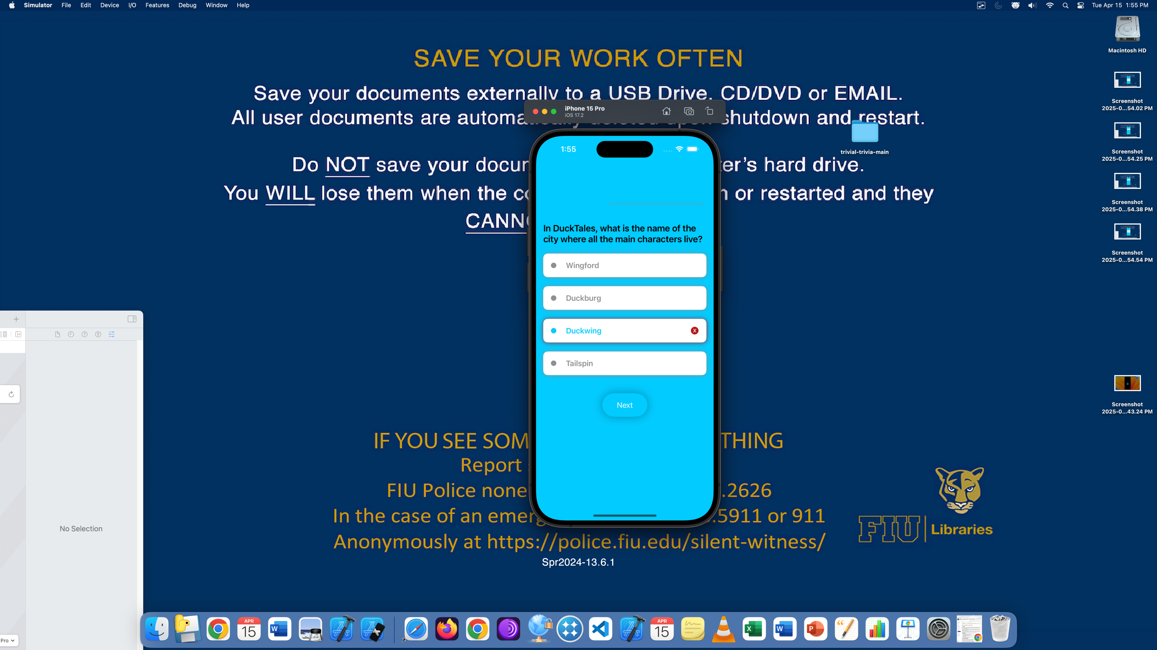

Figure 4: Screenshot from the Trivia Game App

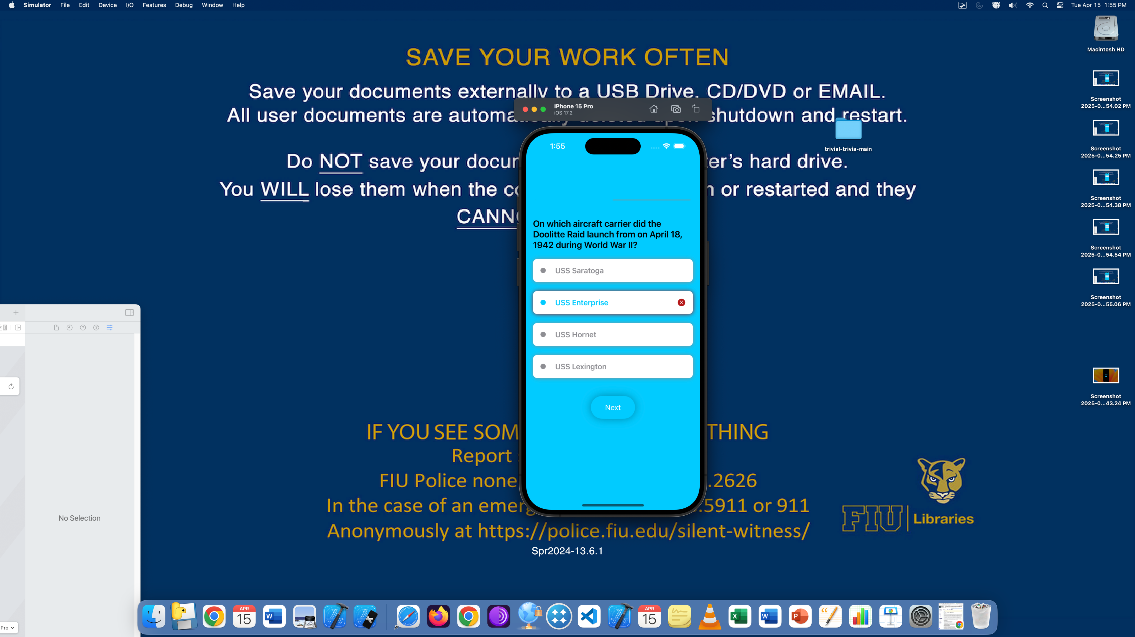

Figure 5: Screenshot from the Trivia Game App

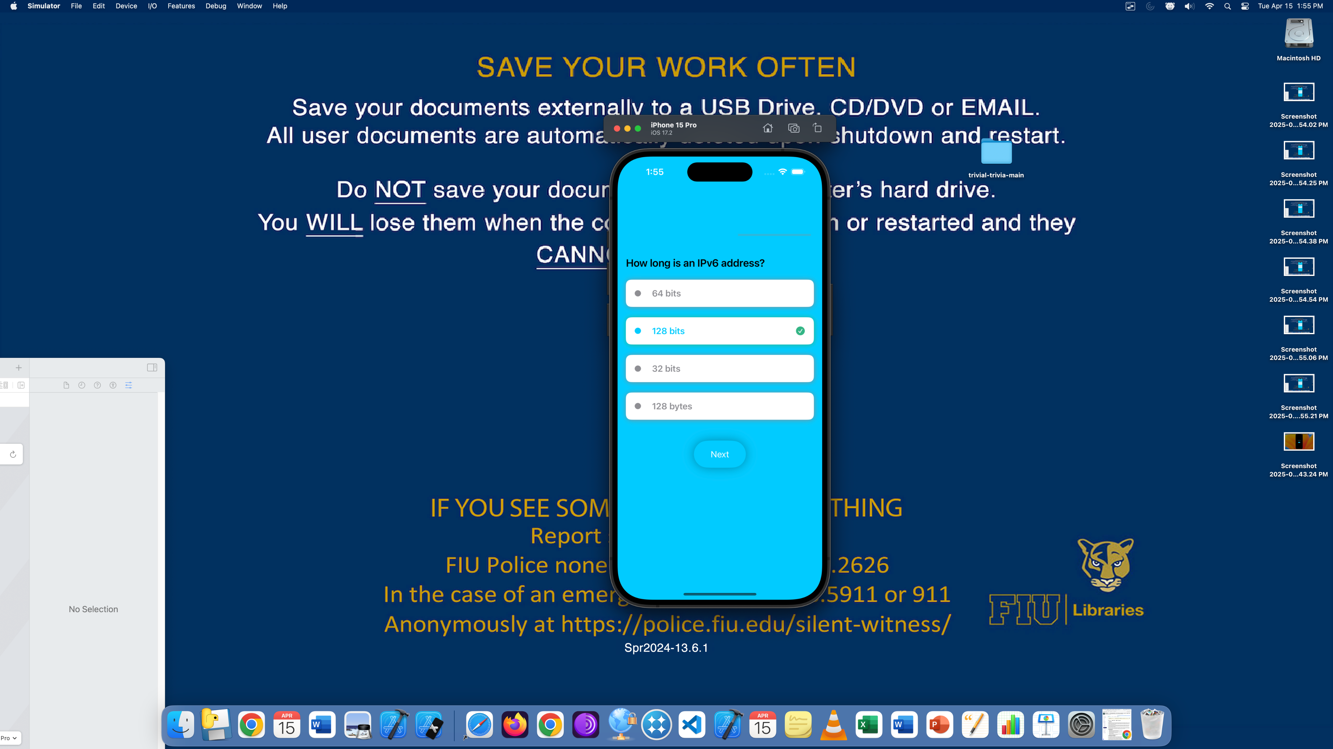

Figure 6: Screenshot from the Trivia Game App

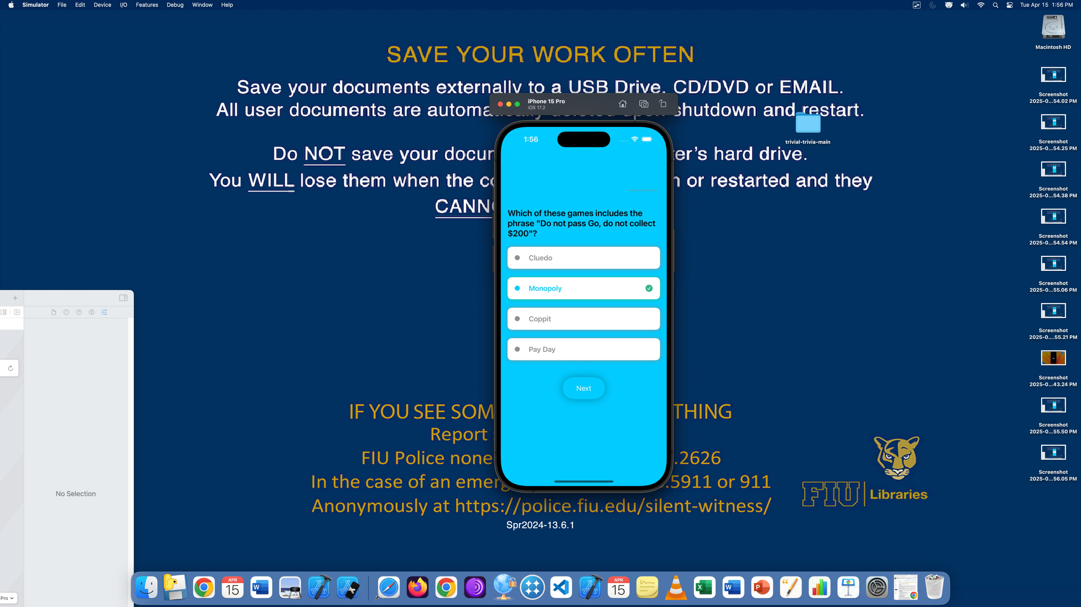

Figure 7: Screenshot from the Trivia Game App

